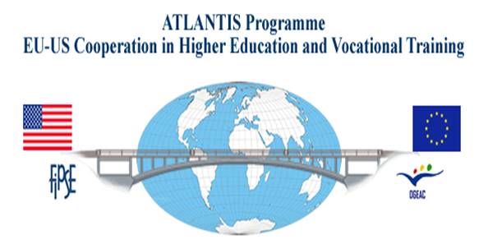
Short-Cycle Higher Education
in the United States and Europe:
Educational Partnerships for Economic and
Community Development

International Symposium
October 15-17, 2009

Toledo, Ohio
Owens Community College Audio Visual Center 567.661.7027
Post-Symposium Social Events
Bus leaves at 9:00am
9:30-10:30 Tour of UT
11:00-2:00 Toledo Museum of Art and Lunch (1:00 Glass Blowing Exhibit)
2:00-4:00 Tour of Downtown Toledo and the Docks
4:00-5:00 Toledo Zoo
5:30 Dinner at the Zoo

